Mind the Learning Gap:



**The Missing Link in AI’s Productivity Promise**

**Unlocking the multi-trillion dollar productivity prize demands learning and augmentation, together.**

Foreword The Augmented Workforce D.E.E.P. Learning Framework Supporting Information Mind the Learning Gap Report **2**

**Foreword** 3

**The Augmented Workforce**

AI and the augmented knowledge worker 5

Identifying the augmented knowledge worker 8

The size of the prize:How much could AI worker augmentation add to the US economy? 10

Unlocking the promise of augmentation through learning 12

D.E.E.P. Learning Framework

Diagnose: Define your task augmentation plan 14

**Embed:** Instill effective learning in the flow of work 19

**Evaluate:** Measure progress toward an AI-augmented workforce 25

Prioritize: Position learning as a strategic investment 29

Supporting Information

Overview of methodology 35

Acknowledgements 37

References 38

**The pace and direction of progress will depend on how effectively we invest in human learning. Every positive scenario for an AI-enabled future is built on human development. Every negative one stems from neglecting it.”**

##### Omar Abbosh

Chief Executive Officer Pearson

**F**F**o**o**r**r**e**e**w**w**o**o**r**rd**d**

The Augmented Workforce

D.E.E.P. Learning Framework

Supporting Information

Mind the Learning Gap Report

**3**

**Foreword**

My first two years at Pearson have rushed by like an

inspiring and challenging whirlwind. I’ve learned a lot about learning.

I’ve travelled the world, talking to policymakers, business leaders, educators and learners of all ages, absorbing their hopes, their concerns, and their priorities. And I can’t think of a single conversation that hasn’t touched upon the growing impact of AI on work and learning.

For many, AI sparks excitement. It promises breakthroughs in productivity, science, and human wellbeing. For others, it brings great uncertainty. The double-edged sword of excitement and uncertainty is normal in a time of rapid change. But the more I explore these technologies, one truth becomes clear: the pace and direction of progress will depend on how effectively we invest in human learning. Every positive scenario for an AI-enabled future is built on human development. Every negative one stems from neglecting it.

This creates a responsibility for all of us who lead today’s workforce, and one that we embrace at Pearson. Leaders everywhere are seeking clarity and real action steps. This report is designed to help. It offers a clear-eyed view of both the challenges and the opportunities ahead in helping workers better implement and use AI. We believe this is not a choice between people and technology. We believe in the partnership between them. When designed responsibly and with a human lens, AI can be a

powerful force for good.

The real promise of AI lies in enhancing human potential and, essentially, making people better at what they do. As generative and agentic AI tools

become more commonplace, knowledge workers—those whose roles primarily focus on thinking, problem-solving, and applying expertise—are on the front line of change. Productivity in these roles has been under pressure for years. AI offers a chance to turn that around.

But success requires a new approach. Organizations must invert the old model of “deploy technology, then have people adapt to the system.” Instead, learning and augmentation must happen together, from

the start. Our modeling shows what’s at stake: AI-powered augmentation could add between

US$4.8 trillion and US$6.6 trillion to the US economy by 2034. This is around 15% of current US GDP

at the lower range.

Achieving this won’t be easy. That’s why this report serves as a practical guide, grounded in research,

expert insight, and real-world experience. Our D.E.E.P. learning framework sets out how to implement augmentation at the task level, embed learning in the flow of work, measure progress, and elevate learning as a strategic priority. This is learning science applied to the realities of today’s workplace.

One thing is certain: organizations cannot afford to let the gap between technology and workforce readiness widen. They need a strategy for AI-powered work that empowers people through upskilling and lifelong learning. Workers, in turn, must embrace adaptability

and curiosity. Few jobs will remain static; success will depend on collaboration across boundaries.

At Pearson, we believe the true prize of AI is not just workplace efficiency. When we implement AI wisely, we can improve the wealth, health and happiness outcomes of hundreds of millions of people worldwide. Importantly, that requires a renewed focus on learning. When we bring



learning to the forefront of this once-in-a-generation change, we can truly help people thrive and realize the life they’ve

always imagined.

**Omar Abbosh**

Chief Executive Officer Pearson

**F**F**o**o**r**r**e**e**w**w**o**o**r**rd**d**The Augmented Workforce D.E.E.P. Learning Framework Supporting Information Mind the Learning Gap Report **4**



#### “Our modeling shows what’s at stake: AI-powered augmentation could add between

**$4.8 trillion and $6.6 trillion to the US economy by 2034—representing around 15% of its current size, at the lower range.”**

Foreword **Th**Th**e**e**A**A**u**u**g**g**m**m**e**e**n**n**te**te**d**d**W**W**o**o**r**r**k**k**f**f**o**o**r**r**c**c**e**e D.E.E.P. Learning Framework Supporting Information Mind the Learning Gap Report **5**

## AI and the

**A new focus on learning is the imperative.**

## augmented knowledge worker

In just three years, artificial intelligence (AI) has reached over one billion users globally, making it the most rapidly adopted major technology in human history.1

But will AI make companies and economies more productive? Predictions vary, with one report calling AI “the next productivity frontier”2 and identifying

potentially enormous gains; on the other hand, a Nobel Prize winning economist cautions “don’t believe the AI hype,”3 noting the absence of data to support “extraordinary” productivity benefits. And that highlights a salient point: as with previous new technologies, it takes time for hard,

reliable data to emerge.

##### Automation is inevitable. Making people more productive is the real prize.

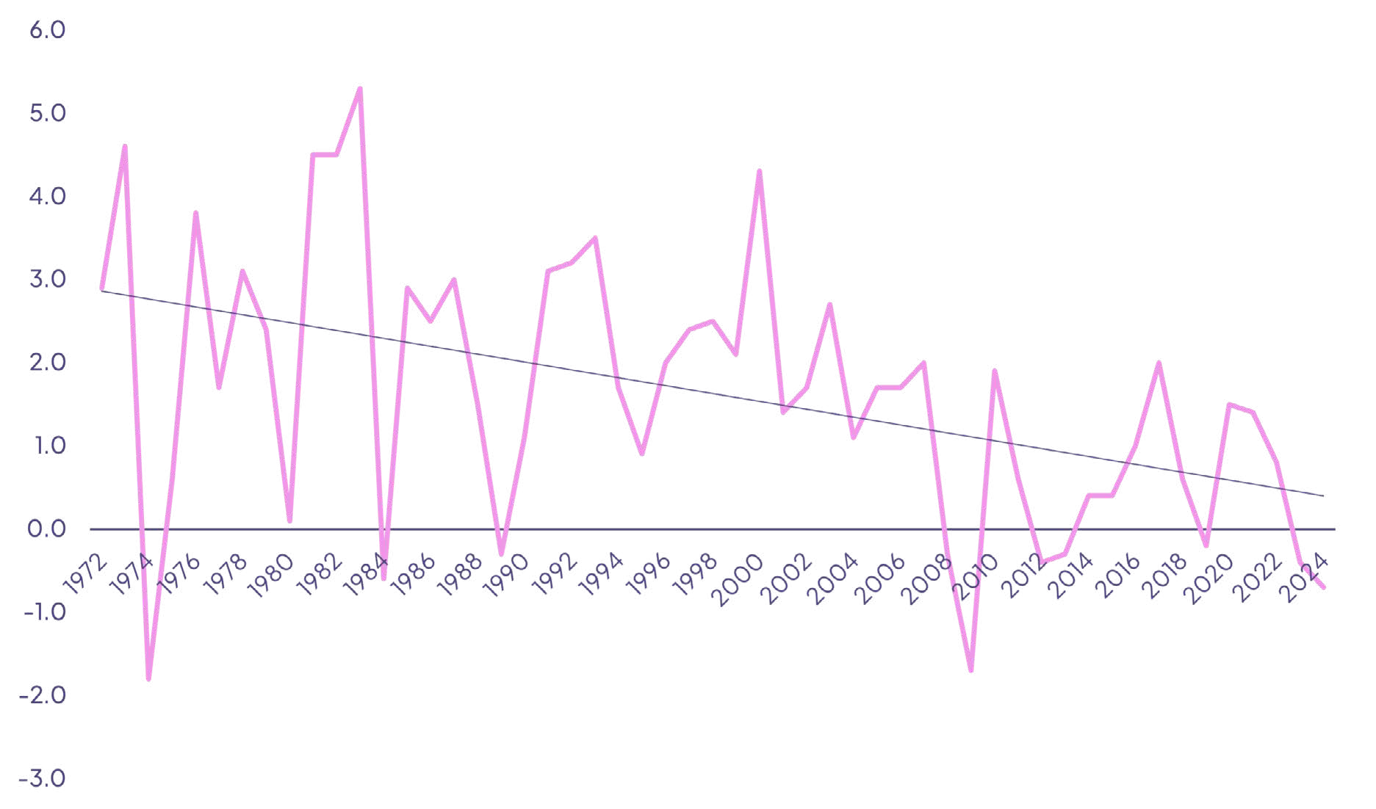

**Figure 1a. UK whole economy output per hour worked, 1972-2024, annual % change**

Source: UK National Statistics. Linear trend line added by authors.

Foreword

**Th**Th**e**e**A**A**u**u**g**g**m**m**e**e**n**n**te**te**d**d**W**W**o**o**r**r**k**k**f**f**o**o**r**r**c**c**e**e

D.E.E.P. Learning Framework

Supporting Information

Mind the Learning Gap Report

**6**

As Michael Osborne, Professor of Machine Learning at the University of Oxford, tells us, “The gains generated by AI are really hard to measure with our traditional productivity metrics, and new innovation always has a time lag to adoption. In fact, we might even see a J-curve effect—a short-term suppression of productivity—as organizations try out pilots, see some walk-backs, and have to re-allocate their investments.”

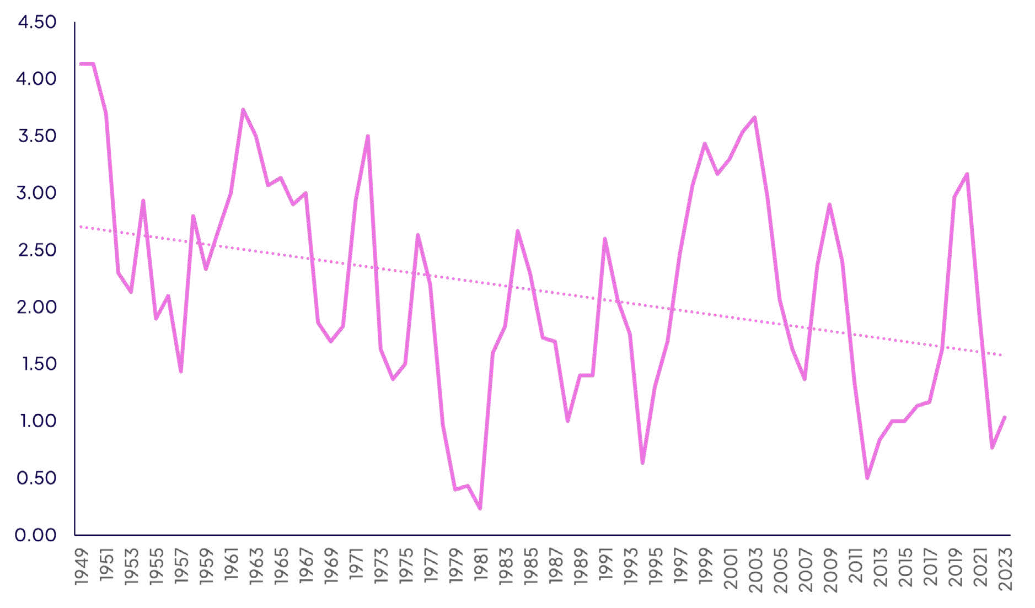

**Figure 1b. Average percent change in US labor productivity, three-year moving average, 1949-2023**

Source: Based on US Bureau of Labor Statistics, labor productivity for all workers in non-farm business sector, annual percentage change (three-year moving average, calculated by authors). Linear trend line added by authors.

Certainly, the recent empirical evidence is far from convincing on AI’s much-vaunted productivity impacts. The UK has seen annual labor productivity growth slump from an average of 3.3 percent in the early 1990s to 2.2 percent in the early 2000s4 to -0.7 percent in recent years.5 The recent evidence for the US, usually regarded as the frontier economy in the creation and diffusion of AI technologies, is similarly disappointing. Consider, for example, that average US labor productivity growth, although often erratic, has declined significantly from the highs experienced in the early 2000s (see Figure 1b). And this at a

time of unprecedented growth in new, powerful AI technologies.

Yet there is a silver lining in the US data, which shows a surge in labor productivity in the mid- to late-1990s, a period that coincided with significant IT investment and digital transformation across many industries.

The message is that technology investment does matter for productivity, although it may take time to see the impact. As we demonstrate in this report, with the right principles and actions for workforce and organizational adoption, there is every reason to expect a similar if not greater trajectory for the economic impact of AI.

Foreword

**Th**Th**e**e**A**A**u**u**g**g**m**m**e**e**n**n**te**te**d**d**W**W**o**o**r**r**k**k**f**f**o**o**r**r**c**c**e**e

D.E.E.P. Learning Framework

Supporting Information

Mind the Learning Gap Report

**7**

##### Automation and augmentation

Meanwhile, CEOs and organizational

leaders must make investment decisions today, when the future returns from AI

investments are shrouded in uncertainty.

An immediate problem is whether to view the impact of AI primarily through the lens of automation—replacing certain human tasks with machines,

or through augmentation—AI that helps human workers to perform their roles better. In popular discussions these are often framed as competing strategies, with automation often, but not always, involving some displacement of labor.

Yet the distinction is not clear-cut. Tom Davenport, Distinguished Professor of Information Technology and Management at Babson College, explains

that it’s not a case of opting for one or the other,

###### Organizations really need the benefits of both automation and augmentation. Automation is very good at productivity and efficiency, but it’s not very good at innovation, or at figuring out whether systems are working well, identifying when you need

to retrain a model, etc.**”**

Mark Esposito, the renowned social scientist at the Berkman Klein Center for Internet and Society at Harvard University, frames the difference

economically: “Automation offers quick, measurable economic returns.” That’s why it’s so favored by finance departments, and by people who want

to show quick benefits to prove a successful pilot project, or to secure further investment. Esposito explains: “Automation can reduce labor costs, recover some of the technology costs, and ultimately, it can optimize an activity that you were already doing.” In contrast, he clarifies, “Augmentation is an economic multiplier. It’s

about longer-term, more transformational returns. Augmentation can fundamentally change the ability of humans to ask and apply questions; it brings

a whole new level of value and productivity.”

The promise of growth is the prize. Andrew Ng, Founder of DeepLearning.AI, puts it succinctly,

###### Ten percent cost savings is nice, but that’s not what excites businesses the most. It takes reengineering the workflows

to get to significant growth.**”**

Put simply, the great promise of productivity from AI investment lies in making people better at what they do with the aid of machine technology. This is the real path to sustainable productivity gains: to build on, accelerate, and enhance human knowledge, expertise, and experience.

See Charting a Path for an Augmented Future at the end of this report for the actions we believe senior leaders need to take.

Foreword **Th**Th**e**e**A**A**u**u**g**g**m**m**e**e**n**n**te**te**d**d**W**W**o**o**r**r**k**k**f**f**o**o**r**r**c**c**e**e D.E.E.P. Learning Framework Supporting Information Mind the Learning Gap Report **8**

## Identifying the augmented knowledge worker

While most types of work can benefit from AI augmentation, our research focuses explicitly on knowledge work. There are several reasons for this. First, there has already been significant use of AI-related technologies in routine manual work—think of AI robotics in manufacturing

and logistics, for example. Second, frontier technologies such as generative AI and agentic AI largely focus on knowledge-related or creative tasks that were previously difficult

for machines to perform. Most importantly, however, knowledge—its creation, diffusion, and usage—lies at the core of long-term productivity growth (technically called total factor productivity growth) in advanced economies, spurring innovation in products, production methods, and ways of doing business.

[See sidebar on page 10: “The size of the prize: How much could AI worker augmentation add to the US economy?”]

What does this augmented knowledge worker look like? Augmentation goes far beyond organizations equipping their workers with the latest AI apps or tools, providing a chatbot assistant or offering training in the rudiments of AI. If organizations commit to enabling it, we see several ways that people will use

AI to enhance their work in the future:

**Knowledge codification & dissemination:** Leveraging AI to capture and share expertise across digital and human teams.

**Data gathering & ideation:** Employing AI to streamline research and challenge conventional thinking.



**Multi-agent collaboration:** Orchestrating complex tasks with digital agents, while applying human judgment.

**Rapid & continuous learning:** Using AI and data to learn in the flow of work, accelerate proficiency and continuous improvement.



**Personalized coaching:** Treating AI as a personalized performance coach that builds persistent memory across locations and roles of strengths and growth areas.



**Seamless human-AI teamwork:** Operating fluidly across human and digital teams to unlock new efficiencies and growth



The augmented knowledge worker is also central to unlocking the broader macro-economic growth benefits of AI investments—conspicuously absent to date. Our detailed modeling of over 300 knowledge-intensive occupations in the US shows that, under a range of scenarios, AI-powered worker augmentation could add between US$4.8 trillion and US$6.6 trillion to the US economy by 2034.

Foreword

**Th**Th**e**e**A**A**u**u**g**g**m**m**e**e**n**n**te**te**d**d**W**W**o**o**r**r**k**k**f**f**o**o**r**r**c**c**e**e

D.E.E.P. Learning Framework

Supporting Information

Mind the Learning Gap Report

**9**

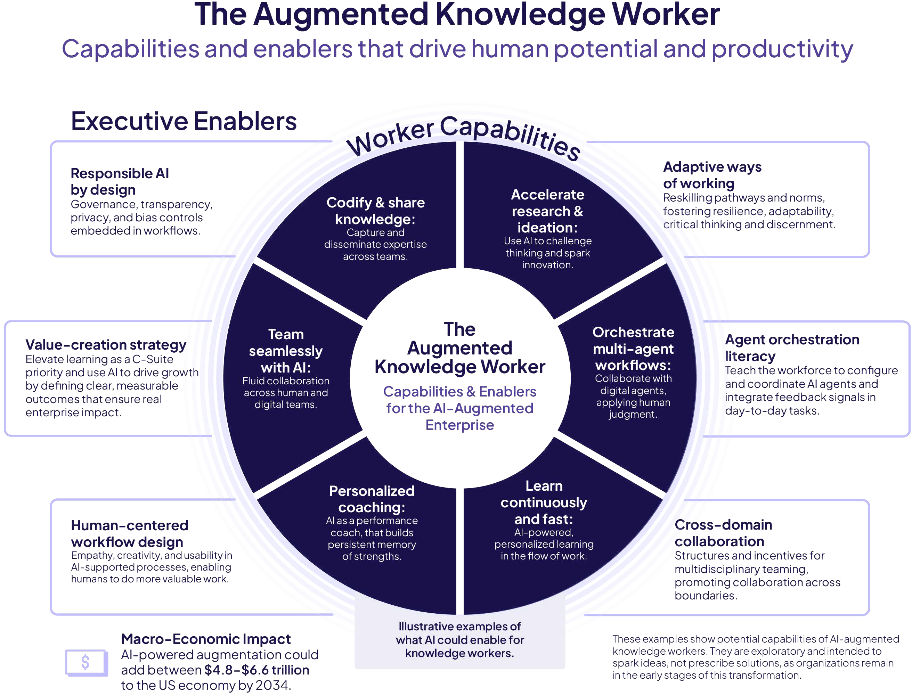

Foreword

**Th**Th**e**e**A**A**u**u**g**g**m**m**e**e**n**n**te**te**d**d**W**W**o**o**r**r**k**k**f**f**o**o**r**r**c**c**e**e

D.E.E.P. Learning Framework

Supporting Information

Mind the Learning Gap Report

**10**

**Sidebar**

# The size of the prize

**How much could AI worker augmentation add to the US economy?**

AI-powered augmentation, properly implemented, can help national economies escape the low productivity trap and boost long-term economic growth. To understand what is at stake for national economies, we modeled the potential future gains to the US economy from faster AI augmentation of knowledge work under several different scenarios.

Our analysis provides a unique insight into the impact of AI augmentation through the lens of specially constructed occupational productivity estimates.

##### Methodology

Our proprietary analysis estimates how artificial intelligence could boost the productivity and economic contribution of a cohort of knowledge workers in the United States. Knowledge workers are professionals whose jobs primarily involve thinking, problem-solving, and applying expertise rather than manual labor. By understanding how many of these workers exist, what economic value they create, and how much AI could enhance their productivity, we can estimate the potential economic gains from AI augmentation.

An immediate problem, however, is that data on occupations—lawyers, accountants, engineers, etc.— is not generally available. Our approach overcomes this challenge by deriving estimates for occupational productivity using data on industry gross-value added (GVA, a close approximation of GDP) per worker, the industry distribution of occupation employment, and relative wage rates across occupations. Armed with a unique dataset of productivity for more than 300 knowledge-intensive occupations, we can then apply data on augmentation probabilities and evidence from the literature on AI productivity impacts to estimate the potential economic gains from AI augmentation by 2034.

A summary of the detailed steps is set out in the Supporting Information section. In essence, the core idea is that the economic impact of AI augmentation will be determined by three key factors: the estimated current productivity of knowledge workers (GVA per worker); the extent to which AI augmentation increases productivity (from the academic and practitioner literature on AI and productivity); and the degree to which different

occupations are augmentable by AI. We used augmentability scores from Pearson’s Faethm database, which tracks emerging and trending skills and job categories, for 264 occupations, to identify the likely extent of augmentation for each occupation by 2034. We used proxies for a small number of occupations (40) for which Faethm data was unavailable.

To give a worked example, if the estimated current GVA of an accountant is around US$350,000 per year, with an augmentability of 19% and an estimated productivity uplift from AI of 7%, then the projected increase in GVA per accountant is US$4,655 (in 2024 prices). These occupational estimates are then combined with 2034 employment projections for accountants to estimate the potential increase in economy-wide GVA from AI augmented accountants by 2034. A similar process is followed for the other 303 occupations we examined.

**Assumptions and caveats**

None of these estimates should be regarded as a forecast of the future economic contribution of AI through knowledge-worker augmentation. These are modeled projections based on data and a set of assumptions about what might happen in the future. For example, the AI augmentability of workers could end up being higher or lower, depending on national and corporate policies around AI investment, education and training, and AI infrastructure. If augmentability turned out to be lower than is assumed here, then the economic gains would fall. It is also important to note that occupational productivity can be hard to estimate for certain occupations and sectors—for example, teachers in non-market sectors such as education or public-sector workers providing governmental services. We have not explicitly modeled automation leading to the displacement of workers from existing roles. While such strategies can boost short-term profitability for enterprises, they may increase or decrease GDP depending on what happens to the displaced workers.

Foreword

**Th**Th**e**e**A**A**u**u**g**g**m**m**e**e**n**n**te**te**d**d**W**W**o**o**r**r**k**k**f**f**o**o**r**r**c**c**e**e

D.E.E.P. Learning Framework

Supporting Information

Mind the Learning Gap Report

**11**

**Sidebar: “The SIze of the Prize: How much could AI worker augmentation add to the US economy?”**

**Results**

Our analysis shows that AI-powered augmentation of knowledge workers could deliver significant economic gains to the US economy by 2034 (see Figure 2). Under a conservative scenario, where the productivity elasticity (impact from AI augmentation) is 7%, AI augmentation of knowledge workers could add an estimated **US$4.8 trillion to the US economy by 2034.**

This would be equivalent to 15% of the current size of the US economy. A moderate scenario based on a productivity elasticity of 10% would grow the US economy by **US$5.4 trillion.** An optimistic, high adoption scenario would magnify these gains still further, to around **US$6.6 trillion** by 2034.

**Figure 2. Estimated impact of AI worker augmentation on US economy (GVA) by 2034, (US$, 2024 prices)**

7

50%

6

40%

5

30%

4

3

20%

2

10%

1

0

0%

Conservative Moderate Optimistic

US$ trn gain % change

Note: The percentage change shows the potential increase in GVA that augmentation can bring to our cohort of knowledge workers by 2034

**4.8**

**5.4**

**6.6**

Foreword **Th**Th**e**e**A**A**u**u**g**g**m**m**e**e**n**n**te**te**d**d**W**W**o**o**r**r**k**k**f**f**o**o**r**r**c**c**e**e D.E.E.P. Learning Framework Supporting Information Mind the Learning Gap Report **12**

## Unlocking the promise of augmentation through learning

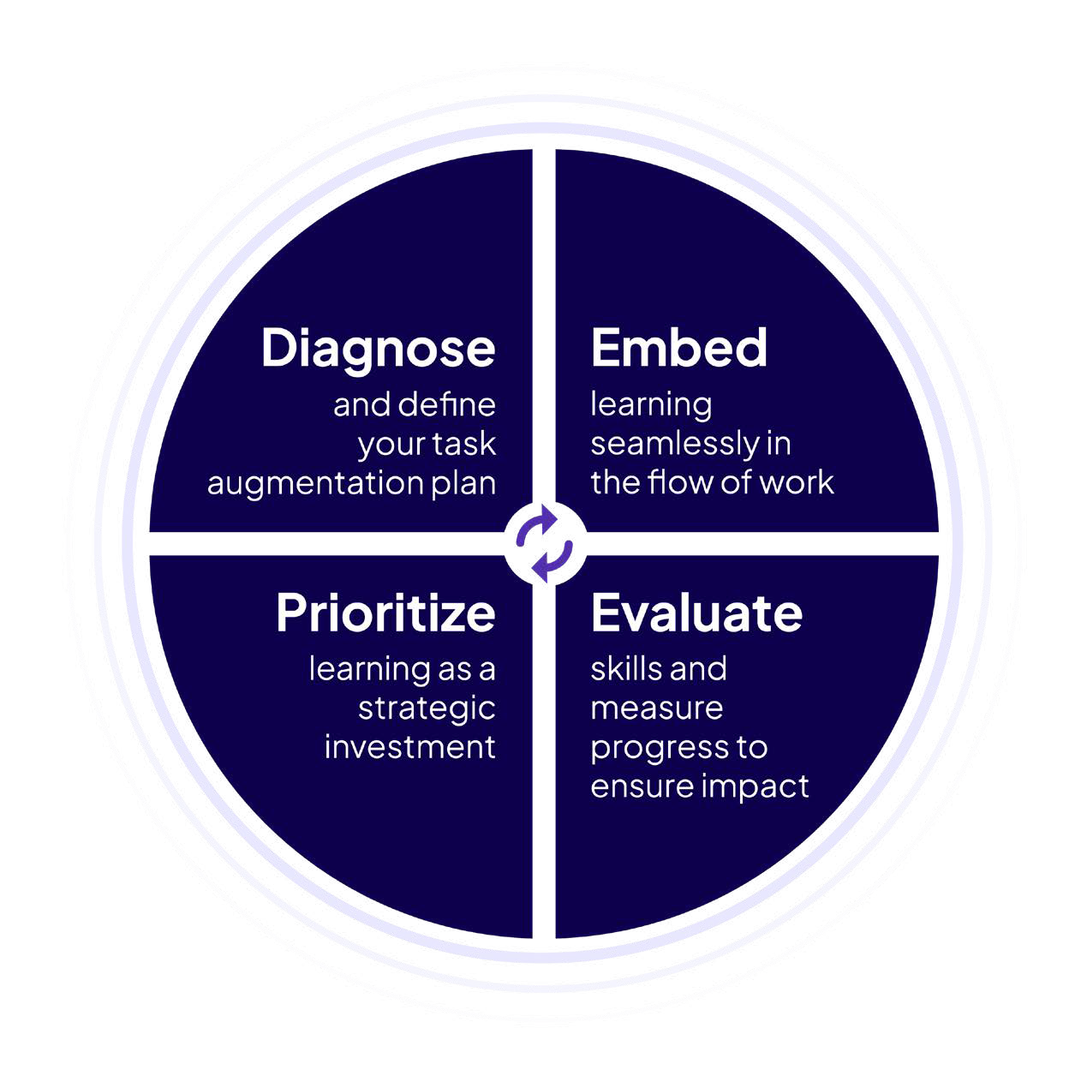

Regrettably, the economic prize of AI-augmented economic growth is far from assured. Insufficient

investment, limited organizational diffusion, and a tendency toward box-ticking AI training initiatives over deeper reskilling all block faster progress. More crucially, however, effective AI augmentation requires organizations to invert the traditional technology-reskilling paradigm, where new technologies—think electrification of assembly lines, or the advent of the Internet—involve major technology investments first,

with worker re-skilling coming later. In contrast, effective AI augmentation requires a process of learning where knowledge workers and new AI systems move in lockstep from the start.

Given the intangible nature of their activities, knowledge workers are best positioned to “identify...the tasks most suited to augmentation, using their experience, expertise and judgment to test strengths and limits.” Both machines

and knowledge workers can learn from each other in the flow of work. Agentic bots can “work-shadow” experienced workers to learn

specialized tasks, while even experts can benefit from new analytical insights provided by powerful knowledge agents. With AI agents freeing up worker time, the locus of knowledge work will swing decisively towards new roles requiring

critical thinking, judgment, and creativity.

This inversion of learning is at a far remove from what we see in many Learning and Development organizations today. There is urgency here: the “learning gap” continues to widen, as investments in technology accelerate ahead of investments

in workforce adaptation. How can organizations start to make this new learning paradigm a reality? What are the necessary steps and accelerators? Our D.E.E.P. framework provides a detailed guide to the journey.

Foreword

The Augmented Workforce

**D**D**.E**.E**.E**.E**.P**.P**.**.**L**L**e**e**a**a**r**r**n**n**i**i**n**n**g**g**F**F**r**r**a**a**m**m**e**e**w**wo**o**r**r**k**k**

Supporting Information

Mind the Learning Gap Report

**13**

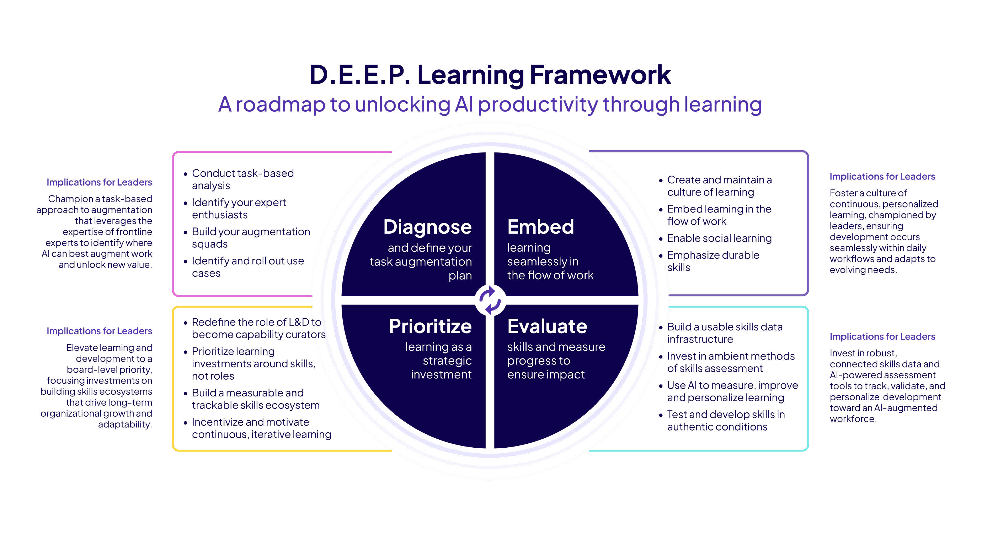

Foreword The Augmented Workforce

**D**D**.E**.E**.E**.E**.P**.P**.**.**L**L**e**e**a**a**r**r**n**n**i**i**n**n**g**g**F**F**r**r**a**a**m**m**e**e**w**wo**o**r**r**k**k**

Supporting Information Mind the Learning Gap Report **14**

## Diagnose:

### Define your task

augmentation plan

Defining an AI augmentation strategy involves multiple steps and phases of work as AI is introduced into the system. The focus ultimately is on understanding the current workforce: the processes they work within, the roles they hold, the tasks they perform, and the new skills they need to apply in light of generative and agentic AI. The evolution of tasks, and the roles that tasks add up to, sit at the heart of the transformation.



Even organizations that take AI seriously, at best, focus on providing their knowledge workers with AI tools, and giving them generic AI training (what AI does, prompting tips, responsible usage, etc.). This is all good and important. At this point, unfortunately, most companies sit back and hope that the employees will then change the way they work, use the tools optimally, and improve productivity. That’s not an AI augmentation strategy, and it’s unlikely to yield results. Instead, the crucial starting point must be to take a closer look at the business outcomes

that can be most effectively achieved through AI augmentation, and the follow-on changes in the tasks that knowledge workers are performing to achieve them. As David Garza, President of Mexico’s Tecnológico de Monterrey Education Group, says, “Given that AI is here, let’s be thinking AI first, and let’s also be thinking what the outcomes are that

we could achieve. And what are those measurable aspects that we can identify that, yes, there is a use case here where the cost-benefit is worth it.”

Foreword The Augmented Workforce

**D**D**.E**.E**.E**.E**.P**.P**.**.**L**L**e**e**a**a**r**r**n**n**i**i**n**n**g**g**F**F**r**r**a**a**m**m**e**e**w**wo**o**r**r**k**k**

Supporting Information Mind the Learning Gap Report **15**



**Diagnose**

##### Conduct task-based analysis

Most of our expert interviewees and the academic literature argue that we need a detailed “task-based” understanding of precisely which activities machines will do, and which activities people will do, for each role. For knowledge-work roles this poses some additional challenges, as Eleanor Cooper, CEO of Pathstream, a performance enablement solution for frontline teams, observes, “Over the course of history we have been gradually increasing the complexity of what humans are expected to do.” In the AI era, no job is fully human or fully automated. Most jobs become hybrid. For the AI-augmented worker, tasks are distributed dynamically between humans and AI tools.

Traditional, task-based job descriptions were written as if work were stable. Roles were defined, documents were filed, and people performed those roles for long periods of time. The arrival of AI means the division

of labor is continually shifting. Tasks that were fully human last year are semi-automated this year and may be

fully automated next year. This demands a new kind of task analysis that focuses on the boundary rather than the bucket:

* What does the AI tool do by default?
* When must the human override or verify it?
* Who is ultimately accountable for the outcome?
* How does the augmentation partnership evolve as AI models improve?
* What is the subsequent higher-value work that the human might do with the free time generated by AI augmentation?

The old task-analysis question—“What does this worker do?”—becomes: “What should this worker do in collaboration with an intelligent system?”

This is the conceptual pivot organizations are only beginning to make. AI does not simply reshape tasks; it reshapes our understanding of work, responsibility, and human agency.

Companies that fail to articulate this new understanding will design jobs that are efficient but hollow; productive but dehumanizing. Mark Esposito describes how, “if there are tasks where you feel like you’d love to have more support, that could be a good candidate for augmentation, because they’re also tasks that you don’t want to fully delegate to technology because you want to keep them as human-centric.” Companies that succeed will treat task-based analysis

not as an engineering discipline but a human one—one that names, preserves, and elevates the tasks that make work genuinely human.

Once AI handles many of the repetitive tasks that it is well designed for, the distinctive human value lies in capabilities, not just

task execution. The center of gravity moves from doing to discerning. Durable capabilities will include things like meta-cognition, problem framing, systems thinking, judiciousness, and the ability to supervise AI and detect failure nodes.



Foreword

The Augmented Workforce

**D**D**.E**.E**.E**.E**.P**.P**.**.**L**L**e**e**a**a**r**r**n**n**i**i**n**n**g**g**F**F**r**r**a**a**m**m**e**e**w**wo**o**r**r**k**k**

Supporting Information

Mind the Learning Gap Report

**16**

**Diagnose**

Mark Williamson, KPMG’s UK Head of People Consulting, has the view that

**People will be absolutely fundamental to the value we provide to the market. You’ve got to pair human expertise and ingenuity with AI to get the most out of it. If you do this responsibly, and it gets**

**to high-value, rewarding**

**work, that really accelerates what you’re trying to achieve overall and provides measurable impact.”**

So, what are some immediate actions

organizations can take to super-charge their AI augmentation strategy?

Foreword

The Augmented Workforce

**D**D**.E**.E**.E**.E**.P**.P**.**.**L**L**e**e**a**a**r**r**n**n**i**i**n**n**g**g**F**F**r**r**a**a**m**m**e**e**w**wo**o**r**r**k**k**

Supporting Information

Mind the Learning Gap Report

**17**

**Diagnose**

##### Identify your expert enthusiasts

Knowing that task analysis needs to morph, we need to ask the question: How will this happen? Who will conduct the task analysis? It’s not currently anyone’s job. Everybody is already busy, and only the person who actually does the job can truly figure out where and how to use AI to improve it.

When tools are introduced, a focus on the frontline worker means that companies can identify

individuals who Sandra Loughlin, Chief Learning Scientist at EPAM Systems, calls “AI enthusiasts.” One cannot introduce a tool and then expect everyone to use it immediately after training.

Rather, says Loughlin, companies should expect that only enthusiasts and innovators in each role will naturally and willingly experiment and use the tool in the context of their work. These workers, says Loughlin, experiment, fail, try creative solutions and eventually learn how to use the AI to actually augment their tasks (and which tasks to augment). This step “cannot be leap-frogged,” Loughlin notes. “It’s the only way to build the basis for use-case specific training which should then be rolled out broadly and expected to drive impact.”

Michael Osborne notes that a common mistake companies make is to “parachute” in technologists from a central data-science department (or worse, from outside the company), to implement an AI solution for a particular role. That approach is

inadequate because, as noted, only the frontline worker who actually does the job understands the real-life context and complexities of the daily tasks they perform. They are best placed to experiment and understand the augmentation opportunities, and must be a central part of the process.

Several experts we interviewed talked about at

least two different groupings of expert enthusiasts. Some are experts identified and assigned early on because of their recognized experience and tacit knowledge that gives them fluency with using the tool in impactful ways. Others will be workers whose expertise cannot be anticipated because it will arise from the interaction with the tool and the resulting evolution of what is possible with AI augmentation. Companies should be quick to identify these “new experts” and leverage them to drive innovation

and learning. David Garza suggests organizations involve, “teams of what I call ‘shakers,’ specialized teams fully dedicated to disruption, to say well, we are here to see how we can leverage the use

of AI in the organization... that’s where I’ve seen many of the good use cases come from early on.”

Foreword

The Augmented Workforce

**D**D**.E**.E**.E**.E**.P**.P**.**.**L**L**e**e**a**a**r**r**n**n**i**i**n**n**g**g**F**F**r**r**a**a**m**m**e**e**w**wo**o**r**r**k**k**

Supporting Information

Mind the Learning Gap Report

**18**

**Diagnose**

##### Build your augmentation squads

Expert enthusiasts will be at the core of what we call “augmentation squads.” These groups will also include:

* Technologists who introduce appropriate tools and ways of using them.
* Operational managers who observe and record, and also leverage AI to glean first-hand knowledge of people’s interactions with the tools.
* Learning and Development (L&D) professionals who translate observations into training.

Those L&D professionals take on increased importance in an augmentation environment. They are no longer simply responding to training requests. In an AI-augmented environment, they

act as capability architects who: map evolving AI-driven workflows to human roles and competencies; forecast capability gaps not yet visible to the business; and design ecosystems (not just

courses) that keep workers adaptable amid rapid change. Ultimately, this moves L&D from reactive support to a more strategic role. At Cognizant, Chief Learning Officer Thirumala Arohi tells us,

“It’s the job of the learning department to not just be the shapers and architects of the future ways of learning and learning models but they must also architect experiences that connect talent development

**and learning programs to business outcomes, ensuring the workforce is ready for tomorrow’s challenges.”**

Together, members of the AI augmentation squad move beyond the implicit assumptions of algorithms, adding critical context and nuance that the AI system could never know. The squads enable bespoke tailoring of the technology to be relevant to the use case at hand. For example, what’s the problem we’re solving? Where is the value to be realized? The technologists will work hand-in-hand with the data owners and workers to get the relevant inputs. Otherwise, as Michael Osborne puts it, it’s “rubbish in, rubbish out.”

Over time, AI itself will increasingly assist with this task-analysis process. Manual observation and data collection is labor-intensive and often limited to a narrow slice of roles. It requires interviews, workshops, and manually coded observations, making it difficult to scale across the enterprise.

AI is beginning to change that, reducing the time and cost of this discovery process.

##### Identify and roll out use cases

From the work with enthusiasts and augmentation squads will arise use cases that then inform training approaches. This is happening right now at Jobs for the Future (JFF), for example. Maria Flynn, President & CEO of JFF, tells us that their employees and executives are being both intentional and iterative with use case development, investing in leveraging a set of power users to do beta testing, focused

on what the expert enthusiasts find useful.

Some use cases can improve productivity quickly, but others will see their value grow over time. Leaders,

especially in L&D functions, should seek out use cases that boost knowledge and long-term productivity.

Sandra Loughlin recommends that leaders “observe the people who are on their own using the tool and coming up with new use cases, being creative, trying stuff out. Find out who your enthusiasts are and use them to get ideas. Then you can get to real impactful training, which will be very concrete, tactical, and valuable.” Some of these use cases may not deliver quick hits to the bottom line, but they will be crucial to developing new capabilities and innovations for the future and, by identifying the employees responsible, will provide new expert enthusiasts who can continue to champion the innovation possible with AI.

As use cases are documented and validated, L&D is tasked with the development and rollout of

use case training. This is where the insights and lessons from individual experts are multiplied to achieve organization-wide value and impact.

**In sum, this task-based approach reinforces the importance of bottom-up diffusion, supported by**

**a top-down framework for guidance. Bottom-up: the frontline knowledge workers rigorously explore and discover how AI will augment their jobs in real life. Top-down: a guiding strategy led from the top, turns those individual lessons into broad-based learning programs and, ultimately, transformed practices and productivity gains.**

Foreword The Augmented Workforce

**D**D**.E**.E**.E**.E**.P**.P**.**.**L**L**e**e**a**a**r**r**n**n**i**i**n**n**g**g**F**F**r**r**a**a**m**m**e**e**w**wo**o**r**r**k**k**

Supporting Information Mind the Learning Gap Report **19**

## Embed:

### Instill effective learning in the flow of work

Even the most advanced industries and organizations are still at the experimental stage with AI augmentation. The time required



to identify task-specific, use-specific and role-specific changes is unpredictable, and only then will future skills demand become

clearer. But while that strategy evolves, one thing is already apparent: organizations cannot afford to wait to strengthen how their people learn. Building a strong foundation for learning now will not only prepare workers for the coming changes, it will make the transition faster, smoother, and more successful when the strategy is ready.

Jacqui Canney, ServiceNow’s Chief People and AI Enablement Officer, champions this approach,

“Learning is the engine of AI enablement. If we want our people to not just use AI, but to shape how it’s used, we need to embed continuous learning into the fabric of every role. At ServiceNow, we’re not treating AI literacy as optional. We’re treating it as a leadership skill, a growth path, and a business imperative.”

In this urgent context, current approaches to AI

upskilling are generally inadequate. All too often, when reporting to investors, many boardrooms are satisfied with ticking the box that AI training has been delivered to X number of workers. Yet such training

is often cursory, focusing on introducing tools along with a beginner’s explanation of how to use them. This

does not come close to ensuring that those workers are actually learning for the coming AI era in a way that shapes knowledge and behaviors and that ensures a workforce has the flexibility needed to adapt quickly.

What’s emerging is a new kind of **“learning gap.”** Employees need to both understand a transformative technology and adapt their skills in response

to its impact on their roles. Fortunately, there are “no regrets” investments that organizations can make now in their workforces to build the experiences, culture, and learning infrastructure required for successful upskilling in the AI era.

Foreword

The Augmented Workforce

**D**D**.E**.E**.E**.E**.P**.P**.**.**L**L**e**e**a**a**r**r**n**n**i**i**n**n**g**g**F**F**r**r**a**a**m**m**e**e**w**wo**o**r**r**k**k**

Supporting Information

Mind the Learning Gap Report

**20**

**Embed**

##### Create and maintain a culture of learning

As AI reshapes the workplace, cycles of upskilling and reskilling will become routine. A culture that embraces learning as an organizational value will be essential. As Mark Williamson says, “Unless you have a learning culture that you are proactively building within your organization, you’re not going to be

able to achieve that rapid and constant skilling and reskilling that you’re going to need to do. You can put in as many programs as you want and provide the

tech, but unless you’ve got that pull from people who really want to develop their skills around it, you’re not going to get close to achieving what you could.”

Research consistently demonstrates how workplace social dynamics, including the amount of support employees receive, can strongly affect how effectively they apply what they’ve learned. “Work environment social support factors can enhance trainee self-efficacy, promote a learning goal orientation, and increase trainee motivation, which in turn can result in desired outcomes including improved productivity, job satisfaction, and a higher likelihood of using trained skills on the job.”6

There are many strategies that organizations can leverage to build a culture of learning. Starting at the top, when leaders visibly model curiosity and experimentation, they normalize learning. Maria Flynn offers a compelling example, “I’ve been sharing how I’ve been using AI in my day-to-day work. I offer examples about what worked and didn’t work. I’m being supportive of employees doing the training, testing and iterating, and sharing with each other.” Leaders have a critical

role to play in setting the right tone on the importance and priority of experimentation.

Policies must also evolve to make learning time visible and protected. Joshua Wohle, CEO of Mindstone, suggests that when companies run synchronous formal training (such as an hour per week for four weeks) they should keep that hour blocked on employees’ calendars for the rest of the year as “experimentation time.” This “publicly signals to the rest of the organization that it’s OK to take that hour every week to just

try something new using AI.” Similarly, integrating AI experimentation into organizational goals or Objectives and Key Results (OKRs) reinforces its

importance. Erin Rifkin, Managing Director of Cloud Learning Services at Google, notes that this ensures that companies are “systematically encouraging and rewarding employees for embracing AI.”

Fostering a culture of learning also means empowering internal champions, who are often more junior employees that can influence organizational culture, bottom up. Sudeep Kunnumal, Chief HR Officer

at Tata Consultancy Services (TCS), describes an innovative program called “reverse mentoring,” where senior leaders are paired with younger employees

as they upskill on AI. According to Sudeep, “Our senior leaders have a ‘human copilot’ and these are the Gen Z employees who are AI natives, and they have really made a phenomenal difference.” This has also enabled leaders to see great talent at all levels within the organization and understand “how you can sponsor [early career employees] to be successful.”

Foreword The Augmented Workforce

**D**D**.E**.E**.E**.E**.P**.P**.**.**L**L**e**e**a**a**r**r**n**n**i**i**n**n**g**g**F**F**r**r**a**a**m**m**e**e**w**wo**o**r**r**k**k**

Supporting Information Mind the Learning Gap Report **21**

**Embed**

##### Embed learning in the flow of work



AI has the potential to finally make real what learning theorists have hoped for decades: learning that

is personalized, embedded in real work tasks, and dynamically responsive to performance data. In this way, AI will also be critical in solving the learning gap organizations now face.

Instead of pulling employees away from their tasks for generic training, AI-enabled systems could allow learning to happen continuously, precisely when it is needed, tailored to the individual’s experience and performance, and capable of delivering personalized learning at a scale that was previously impossible.

For example, instead of “one-size-fits-all” modules, employees can receive:

* Just-right difficulty levels.
* Targeted remediation based on misconceptions or gaps.
* Accelerated pathways for those who already know the material.
* Refresher nudges exactly when knowledge decay is likely to occur.

This aligns with a vision that several expert interviewees described: Every employee can have access to a personalized tutor or coach.

Sandra Loughlin imagines “a personalized tutor who’s ‘sitting with you.’ Someone who knows exactly who you are, knows your skills, knows what you’re working on right now, and can make those connections in a way that’s real.”

Similarly, Jayney Howson, Senior Vice President of Global L&D at ServiceNow says,

##### The idea is that employees have an always-on personal professor or

**an AI companion who is recommending, based on their behavior, the training that they need to do in the moment.”**

Jeana Jorgensen, Corporate Vice President of Worldwide Learning at Microsoft, describes creating an agent that has contextual knowledge and a personality modeled

after their top leaders that sales team members can refer to whenever they have questions. She says this tool helps employees “feel like they’re learning directly from Microsoft leaders. This has created greater psychological safety in a way we didn’t anticipate.”

Foreword

The Augmented Workforce

**D**D**.E**.E**.E**.E**.P**.P**.**.**L**L**e**e**a**a**r**r**n**n**i**i**n**n**g**g**F**F**r**r**a**a**m**m**e**e**w**wo**o**r**r**k**k**

Supporting Information

Mind the Learning Gap Report

**22**

**Embed**

Other learning techniques that AI could enable include:

* Surfacing micro-lessons exactly when a task is being performed.
* Offering contextual tips, examples, and warnings based on real-time system data.
* Automatically detecting where an employee might struggle—before a mistake occurs.
* Integrating learning prompts directly into software interfaces, dashboards,

or communication tools.

Feedback, another critical component of learning, has historically been hard to scale. With AI tools, individual feedback that is actionable, applicable, and based

on holistic data gathered across a wide range of activities is now possible. Sandra Loughlin notes that,

##### AI is extremely helpful in essentially closing the gap between knowledge, practice, and feedback … AI creates the opportunity for us to go and ask a more knowledgeable

**other for feedback”**

Finding time to learn at work is a key challenge, but with AI, an individual’s daily work becomes both the learning content and the learning platform.

Rather than pulling employees out of work to learn, AI allows learning to happen in the moment.

James Cook, Senior Partner for Workforce Productivity at IBM, describes how learning could be provided through an employee’s AI assistant. In addition to completing a certain task, the assistant could be mindful of the unique skills

the human employee needs. For example, “the assistant could be saying, ‘by the way James, I’m doing Y for you. You now need to know X, and here’s a little bit of tutoring for you’…If the assistant itself can say ‘here’s the skilling I need to give

you,’ that really is learning in the flow of work.”

This vision aligns with common organizational goals for learning that often target ‘less time away from

the desk.” As Dr Philippa Hardman, Creator and Founder of DOMS™️ the AI-enhanced learning design framework and host of the AI & Learning Design Bootcamp, describes

**learning in the flow of work appeals to executives because the biggest cost of workplace learning isn’t content, expertise, or tech—it’s time not working.**

**Shift even 5% of training into the flow of work and the savings from less time away**

**from the desk are massive. The efficiency gain is simple: people don’t stop working to learn—work and learning become**

**essentially indistinguishable.”**

Some AI learning tools already exist; many others are being developed; still more powerful ones are being imagined for the future. If an organization is not already piloting or scaling such tools, there’s an imperative for the L&D team to take action. When

paired with a strong learning culture and well-trained managers, these capabilities can significantly

accelerate skills development and help ensure that AI upskilling efforts deliver lasting impact.

Foreword

The Augmented Workforce

**D**D**.E**.E**.E**.E**.P**.P**.**.**L**L**e**e**a**a**r**r**n**n**i**i**n**n**g**g**F**F**r**r**a**a**m**m**e**e**w**wo**o**r**r**k**k**

Supporting Information

Mind the Learning Gap Report

**23**

**Embed**

##### Enable social learning

Not all learning is formal. Much of the learning that happens within organizations results from employees sharing their knowledge, experiences, and lessons with one another. As Jayney Howson says, “Especially for the base-level AI work, AI knowledge is ‘caught, not taught’ and people will just hear other people talking about it and see other people doing it.”

At ServiceNow, their aim is to “orchestrate those

conversations.” To achieve this, organizations should invest in systems that allow internal experts to share their knowledge with others. ServiceNow runs “Colabs,” which are peer-to-peer learning sessions run by subject matter experts within the business.

Erin Rifkin detailed an initiative at Google called “Ai4us” where the organization “incentivizes people to build a marketplace of AI tools that they use in

their day-to-day job and enable people to showcase and leverage them, and give feedback. … It creates opportunities for learning and co-developing.”

Mark Williamson agrees: “Learning from others and learning together is a lot of how it really works for people in terms of learning in the flow of work.” By designing environments that support knowledge exchange, organizations make learning a social norm.

As Joseph Lin, AI Transformation Lead at Goodnotes, describes, AI upskilling is largely about social influence, consistent messaging, and opportunities for sharing. “We’ve created a series of internal trainings that we call AI Foundations, which allow teams to share use cases and reinforce best practices based on our internal tooling and context. It’s become a hot ticket to secure an AI Foundation speaker

slot, because that means you will become a visible figure of the AI transformation within the company. If your example is really cool, other teams will start to reach out and say ‘Oh wow, I didn’t know that I could have a dashboard that looks like that,’ or ‘I didn’t realize you could customize automated follow ups that way!’ Using human networking to put a human face onto all of this is how you get things going.”

Foreword

The Augmented Workforce

**D**D**.E**.E**.E**.E**.P**.P**.**.**L**L**e**e**a**a**r**r**n**n**i**i**n**n**g**g**F**F**r**r**a**a**m**m**e**e**w**wo**o**r**r**k**k**

Supporting Information

Mind the Learning Gap Report

**24**

**Embed**

##### Emphasize durable skills

In an environment where tools evolve rapidly, tasks shift dynamically, and roles continuously change, the decisive advantage belongs to workers who understand how they learn, how they adapt, and how to work effectively in partnership with AI.

Technical skills alone aren’t enough. Organizations must also foster core human capabilities. Our experts highlighted a number of these. Michael Osborne listed off “creativity, social intelligence; skills related to leadership, teamwork, negotiation,

emotional intelligence, and creative problem solving (in partnership with AI)” as key “human skills” that all workers need to improve. Jayney Howson likewise mentioned “curiosity, agency, accountability,

agility, critical thinking, human connection, and communication.” A newly important skill highlighted by Maria Flynn is that of “discernment, or the ability to tell whether an AI output is good or how it needs to be changed”. These skills take time to build, but

leveraging AI-enabled learning tools, as we described above, can aid this endeavor by providing authentic opportunities to develop, practice, and receive feedback on these skills, all in the flow of work.

Perhaps the most critical capability for employees is Learning to Learn, which involves consciously planning how one approaches building new skills and knowledge (as discussed in our 2025 report [**Lost in Transition: Fixing the “Learn to Earn” Skills**](https://plc.pearson.com/en-GB/news-and-insights/lost-in-transition) [**Gap**](https://plc.pearson.com/en-GB/news-and-insights/lost-in-transition)**).** It combines behavioral strategies that make learning efficient with metacognitive strategies that help employees reflect on and regulate their

learning processes. When employees understand what strategies are effective for learning, and

implement them in their daily practices, they become more agile and resilient in the face of ongoing technological change. At the same time, an interest in AI can signal broader curiosity and facility in learning. As Joseph Lin shares, “We look for AI power users because generative AI is only three years old, so anyone who is caught up is probably quite a self-motivated, quick learner. Therefore,

we just ask directly, how do you keep up with AI?”

There are several practices organizations can implement which encourage Learning to Learn skills.

Organizations should:

* Offer employees agency and ownership over their learning pathways by supporting employee-driven development plans and letting them set their own learning goals based on career trajectory.
* Build opportunities for reflection into daily workflows by incorporating routine moments for employees to review what they learned and how they learned it.
* Train managers as learning coaches so they can guide goal-setting, track progress, and help

employees refine learning strategies.

* Equip managers with AI-enhanced insights that reveal patterns in employee learning and performance to strengthen development conversations.
* Deploy AI nudges that prompt employees toward effective learning habits as they learn in the flow of work.

**In a rapidly changing, AI-enabled workplace, organizations gain**

**a decisive edge by cultivating employees’ human skills. These skills can make employees more flexible in a fast-evolving skills landscape; and also make them more effective co-workers with their continually evolving AI-machine colleagues.**

Foreword The Augmented Workforce

**D**D**.E**.E**.E**.E**.P**.P**.**.**L**L**e**e**a**a**r**r**n**n**i**i**n**n**g**g**F**F**r**r**a**a**m**m**e**e**w**wo**o**r**r**k**k**

Supporting Information Mind the Learning Gap Report **25**



## Evaluate:

### Measure progress toward an AI-Augmented workforce

The shift to an AI-powered workforce—where human and machine specialists continually evolve and intermesh—demands a more finely-grained understanding of worker skillsets.

Sandra Loughlin explains, this is not just a learning imperative, but a strategic one: “The reason you need to collect skills data (amongst other data sources around people) is so that you can actually optimize people for the business strategy. People are the engine of your business strategy, so if you don’t have the right people, you can’t realize where you’re trying to go. Likewise, if you don’t know what skills you have in the organization, then you’re just wasting money and time by guesswork in talent activities and L&D programs. Unfortunately, this

is exactly what companies are doing today.”

In a workplace continuously reshaped by AI, having a deep understanding of what employees know and can do is essential. It is the foundation for the “Diagnose”

activities described earlier and enables organizations to implement training and upskilling initiatives to more effectively close the learning gap. By measuring outcomes, organizations can determine which

interventions are working, optimize those efforts, and refine or rethink approaches that are falling short.

So what can organizations do to take stock of their existing workforce skills and track progress to AI-augmented work? Our research highlights several practical actions, from getting better control of data to the use of AI technology itself.

Foreword

The Augmented Workforce

**D**D**.E**.E**.E**.E**.P**.P**.**.**L**L**e**e**a**a**r**r**n**n**i**i**n**n**g**g**F**F**r**r**a**a**m**m**e**e**w**wo**o**r**r**k**k**

Supporting Information

Mind the Learning Gap Report

**26**

**Evaluate**

##### Build a usable skills data infrastructure

Much data about employee skills and activities remains dispersed, inaccessible, or out-of-date.

“Generally, organizations aren’t as good at collecting human data as they are around creating deal data or product data,” says ServiceNow’s Jayney Howson.

This makes it hard to get a view of the knowledge worker in the round, what Howson describes as “connected human data.” For example, a sales executive might have training data residing in a learning database, qualifications in an HR database, and sales performance data in an enterprise resource planning (ERP) system. Getting that data connected creates what Howson calls a “talent signature” for

the worker, which can then be used to direct the right learning resources to the individual. While this has traditionally been a challenge, emerging technology is beginning to alleviate this persistent pain point.

Thankfully, modern enterprise data systems can streamline much of the work of getting all of the data in one place. One approach is data consolidation through data warehouses, which can then be accessed centrally. However, when

data is dispersed across multiple legacy systems in different formats, such centralization can be costly and time-consuming. An increasingly popular approach is the use of “data fabrics” which use AI capabilities to extract and analyze the data in its existing location without moving it around.

Such fabrics have real potential for organizations, bringing the prospect of generating up-to-

date talent signatures a step closer to reality.

Mark Williamson is optimistic around the data possibilities. “In this new world, you’ve generally

got the data within the organization to be able to demonstrate those things, but of course it’s making the causal linkages between a new skill

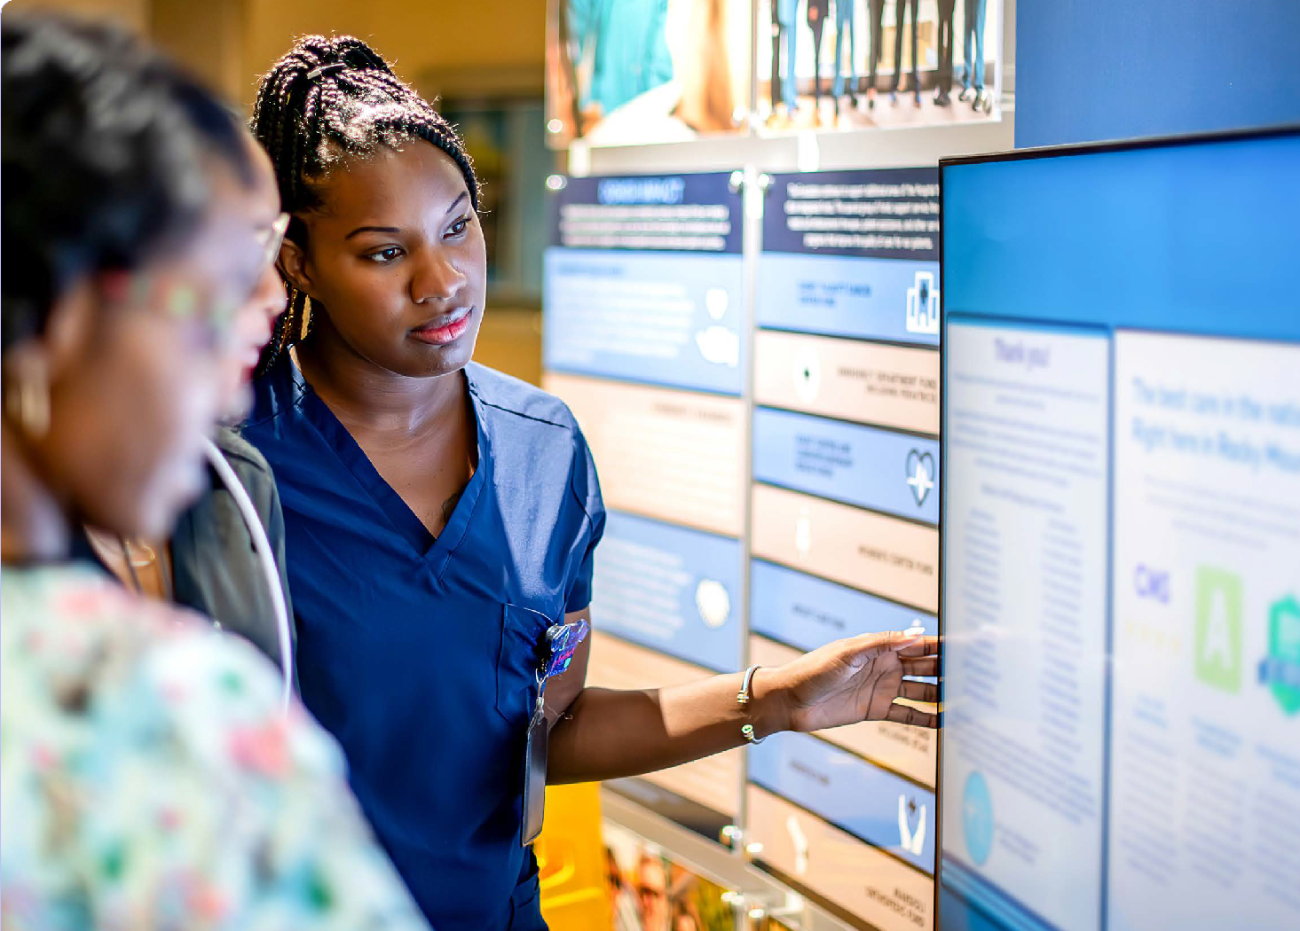and what effect that’s had on a business outcome. Use of AI to measure that can help. If we’re getting a proper understanding of the learning and

reskilling that we’re putting into the funnel, does that equate to what we are seeing come out? It’s about measuring in the here and now, improving, then evaluating what’s been achieved through that. That’s the virtuous cycle we’re aiming for.”

Foreword

The Augmented Workforce

**D**D**.E**.E**.E**.E**.P**.P**.**.**L**L**e**e**a**a**r**r**n**n**i**i**n**n**g**g**F**F**r**r**a**a**m**m**e**e**w**wo**o**r**r**k**k**

Supporting Information

Mind the Learning Gap Report

**27**

**Evaluate**

##### Invest in ambient methods of skills assessment, made possible by AI

AI technology can do much more than data gathering. It can also upend traditional approaches to skills assessment. IBM’s James Cook points to ambient methods of AI-enabled assessment as a potential game changer. Traditional methods of skills assessment typically relied on periodic testing or

self-evaluation of skills through questionnaires and forms. An immediate problem with self-evaluation is that workers may lack insight into their skills,

particularly in fast-moving areas such as technology. Another problem is timeliness: assessments are almost out of date as soon as they are performed.

Ambient assessment uses AI to infer the skills that workers have from their behavior, work artifacts and actions, enabling a more organic approach to skills measurement. Cook explains further: “For many years we’ve been using AI to do skills inference.

We pull over 20 million files on a regular basis to be

able to deduce that ‘James has a particular skill to this level because he’s learnt certain things, he’s worked on this project, he’s published in various places, and so on.’ The AI is pretty accurate and it’s getting even more accurate.” Once skills inference is available, the breadth of skills data widens, giving

organizations more insight into what employees know and can do. Once available, skills can be badged

and credentialed, making this data more valuable for employees. Skills data also serves a learning purpose. AI can use triggers to identify whether skills thresholds have been reached or not, and provide nudges to suggest further training where needed.

##### Use AI to measure, improve and personalize learning

AI technology also offers the transformative prospect of almost-continuous assessment, essential for individuals and organizations in a world of blurring skills boundaries and roles. Already there are many examples of AI coaches and learning assistants

that provide real-time feedback and guidance to learners. AI interview coaches help simulate job interview environments, testing for tone, clarity, and technical knowledge. Sales coaches can advise on conversation cues, personal rapport, and product

knowledge. In industrial environments, AI coaches can help with essential skills such as situational awareness, reaction time and compliance with safety rules. AI-embedded software systems can observe coding skills and advise on problem-solving techniques and coding efficiency. Jayney Howson explains how such

AI coaches can help reinforce learning and personal development: “Let’s say a manager is coming up for their quarterly growth conversation. The AI companion will remind the manager and open up a simulated environment—we call it a playground—where the manager can roleplay that conversation with their supervisor and test their skills in the moment.”

Another benefit of AI-enabled assessment is that it can give precise feedback on skills progress and proficiency. As Jeana Jorgensen explains, “With AI, you can engage in ongoing role play and practice,

and it will score your level of aptitude. You can then be assessed, and when you score 90% or more, you have passed that level of proficiency.” This is a much higher level of specificity than employees typically receive when getting feedback from managers or peers.

Continuous assessment supports organizations as well as employees by creating a powerful feedback loop. Adrian Clamp, Global Head of Strategy and Investment at KPMG Consulting, describes how, at KPMG, “modern AI-driven learning isn’t just about delivering content—it’s designed to continuously assess your progress, identifying how quickly you master concepts and tailoring the experience

to your pace. This means faster understanding, smarter feedback, and a truly personalized learning journey.” When employees are trained in using AI tools in the context of their real work, and those same work behaviors are used to assess progress, organizations gain a much clearer picture of whether learning approaches are working or need to be adjusted, and what progress employees

are making. Learn, improve, measure, repeat.

Foreword

The Augmented Workforce

**D**D**.E**.E**.E**.E**.P**.P**.**.**L**L**e**e**a**a**r**r**n**n**i**i**n**n**g**g**F**F**r**r**a**a**m**m**e**e**w**wo**o**r**r**k**k**

Supporting Information

Mind the Learning Gap Report

**28**

**Evaluate**

**Evaluating progress toward an AI-augmented workforce requires far more than tracking course completions or attendance rates. It demands a system that integrates**

**rich, connected skills data, infers skills**

**dynamically through behavior and output, and embeds learning and feedback in authentic environments. But measurement is only useful if it drives action. The true value comes from how well organizations**

**align their newly understood capabilities**

**with evolving business priorities and enable people to thrive in redefined roles.**

##### Test and develop skills in authentic conditions

It can be argued that nothing beats real-world work for true testing of skills: compared to the classroom, it throws up unexpected events and complications, noise and ambiguity, often in pressure-cooker environments. But such strategies can be daunting for learners and risky for organizations, so the next best thing is testing in highly realistic real-world

situations. Google’s Erin Rikfin explains further:

##### Because skills are evolving so quickly, we need better ways to assess those skills and validate them in a real-

**world scenario of how people actually use those skills.”**

Google’s approach has been to create “Skills Badges” which are generated by learning in a “real-world scenario of a technical use case—it might be using Google Gemini or NotebookLM. After training, the engineer works through the tech without any tips or tricks to test their skills. We think this ability

to validate skills in a hands-on way, rather than through just questions and answers, is going to become more and more critical to organizations.”

Testing in authentic conditions is also an efficient way to understand the realities of present skill levels and to compare that with future skills demands.

Mark Williamson describes the importance of remaining vigilant about how skills are evolving, “The future world involves preparing for new emerging roles and roles that we’ve not even imagined yet. It’s not only what I need to be able to do now, but what are the types of things I will need to be able to do going forward, around those new roles in data stewardship, digital governance, human-centered services, etc.”



Foreword The Augmented Workforce

**D**D**.E**.E**.E**.E**.P**.P**.**.**L**L**e**e**a**a**r**r**n**n**i**i**n**n**g**g**F**F**r**r**a**a**m**m**e**e**w**wo**o**r**r**k**k**

Supporting Information Mind the Learning Gap Report **29**



## Prioritize:

### Position learning as a strategic investment

Now that your organization has successfully reimagined the tasks, identified the required skills, and set in motion effective, measurable upskilling initiatives in the

flow of work, what should you do with your newly skilled, AI-augmented knowledge workers? And more importantly, how do you keep the momentum going?

Several things are clear even in the current state of uncertainty. Learning and upskilling are going to be continuous requirements, and an organization’s competitive edge will be centered on the adaptability of its human workers.

But continuous learning in the face of work redefinition is a complex psychological and sociological challenge that goes beyond traditional skilling initiatives. Employees need support with transitioning into their newly defined roles, and must have opportunities for career mobility to leverage their new skills. These processes require strategic prioritization and strong leadership at the company level for upskilling to be successful.

James Cook deliberately provokes: “Skilling is too important to be left to HR.…It’s a board-level topic.”

Joshua Wohle believes that learning is beginning to be viewed as a strategic imperative in the board room: “A crucial moment is when the CEO and

COO realize they need to shift their thinking on learning.” He argues that “the executive suite has, for some time, largely viewed learning simply as a retention tool. They’d pay it lip service, but didn’t see it as a business driver.” But there’s no escaping the escalating importance of learning. “Now it

matters. Learning and Development budgets should be a top priority…which means the departments themselves need to adapt to today’s needs.”

The growing importance of learning brought on by the advance of AI is inescapable. The topic is

prominent and pervasive in any conference, initiative, or discussion on AI. But as much as policymakers, business leaders and academics agree on the

under-investment and low prioritization of learning, change is slow, and we see little guidance on where organizations should channel their efforts and investments. In this context, we highlight the need to prioritize the transformation of Learning and

Development departments and the creation of a skills ecosystem that incentivizes continuous learning.

Foreword

The Augmented Workforce

**D**D**.E**.E**.E**.E**.P**.P**.**.**L**L**e**e**a**a**r**r**n**n**i**i**n**n**g**g**F**F**r**r**a**a**m**m**e**e**w**wo**o**r**r**k**k**

Supporting Information

Mind the Learning Gap Report

**30**

**Prioritize**

##### Redefine the role of L&D to become capability curators that shape AI-augmentation

AI is catalyzing a profound rethinking of the role of Learning and Development (L&D) from content distributors to curators of capability. L&D is responsible for developing the ability to map,

measure, and maintain visibility into the skills of the workforce. This also requires helping the business realign incentives and structures so that employees are actually motivated to learn. To accomplish this, employees need clear insight into the gap between the skills they have and the skills they need, especially as those requirements shift with the introduction of AI.

As AI reshapes roles and skills demands, leadership must rapidly learn to treat L&D as a crucial strategic investment. This means serious C-level attention and resourcing that is commensurate with its importance.

As Joshua Wohle puts it, “L&D was never seen as an ROI unit. And that created a situation where budgets were allocated accordingly and training, comparatively speaking, has always been a tiny investment compared to the rest of the business.” Adrian Clamp even argues that the shape of the workforce and the skills of the organization should

be owned by the CEO as one of the top three to five priorities, “Learning in the enterprise has evolved to become a strategic imperative. It’s no longer just the responsibility of HR — but is now central to how the enterprise thrives, ensuring the organization has the talent and skills to compete and grow. Today, the

shape of the workforce and the need to re-skill in the age of AI is a board-level priority, deeply connected to business strategy, not the responsibility of the Chief Learning Officer alone.” There’s a growing

realization that the AI era demands a profound transformation in the roles and responsibilities assigned to Learning and Development.

Given that AI is the driving force behind these changes, AI skills among HR and L&D professionals are an important place to start: “Our biggest lesson learned is that the most effective AI transformations start by building HR’s capability first,” declares

Stephanie Kneisler, Vice President of Strategic Enablement and Engagement at ServiceNow. Her point is that the people preparing others to work with AI should understand how to work with AI themselves. “We’ve put extraordinary

expectations on HR to redesign work, reskill talent, and shepherd people through constant change. If HR professionals aren’t AI-fluent and anchored in talent strategy and change management best practices,

they’re being asked to lead a transformation they haven’t been equipped to navigate.”

Those AI skills must be combined with a shift away from content creation toward actual facilitation of learning. EPAM’s Sandra Loughlin sees the advent of AI as a stimulant for a radical expansion

in L&D responsibilities, including: “measuring and documenting the skills of people (not just from a specific training program); motivating people to learn; providing transparency to the evolving skills landscape (both supply and demand); building opportunities for informal learning (which is how most people learn most things); and evaluating the pipeline of learning skills outside the organization.”

The list is daunting but clear-eyed, and Loughlin acknowledges how far we are today from her vision of the future. So, how can we move toward that future?

Foreword The Augmented Workforce

**D**D**.E**.E**.E**.E**.P**.P**.**.**L**L**e**e**a**a**r**r**n**n**i**i**n**n**g**g**F**F**r**r**a**a**m**m**e**e**w**wo**o**r**r**k**k**

Supporting Information Mind the Learning Gap Report **31**

**Prioritize**

##### Prioritize learning investments around skills, not static roles

Shifting job requirements are the antithesis of traditional, static roles. Yet, shifting job requirements are what we know to expect more of.

So, it’s regrettable that most organizations structure their workforce and learning plans around static roles. Skills, on the other hand, act as reliable building blocks that can be moved across shifting job

requirements. A focus on skills targets what people need to do, rather than the title they hold, allowing more adaptability and a clearer connection between people and business objectives. As Sandra Loughlin puts it: “If you don’t know the skills of your people, it’s impossible for you to make good decisions about mobility, learning, and many other talent activities.”

Skills-focused learning also allows greater

agility for aligning with customer needs.



As Thirumala Arohi describes, “Cognizant develops skill clusters and learning programs through multiple lenses—one of them being our view on Growth and Emerging Skills, another one dedicated to client-specific needs.” He gives an example: “If a client prioritizes robotics but defines it differently than we do, we adapt by creating tailored learning programs that align with their vision, ensuring we deliver value on their terms.”

**The onus for shifting the focus from roles to skills primarily lies with organizations, not workers. For employees to embrace an emphasis on skills, skills must be at the center of real decisions and incentives regarding hiring, promotion, and**

**development. James Cook describes what this looks like at IBM: “We took a big step forward a number of years ago by saying you can’t get promoted unless you have the following Skills Badges.” This kind of skill-based decision-making is only possible when organizations build the infrastructure that makes skills development tangible,**

**verifiable, and actionable.**

**Prioritize**



Foreword

The Augmented Workforce

**D**D**.E**.E**.E**.E**.P**.P**.**.**L**L**e**e**a**a**r**r**n**n**i**i**n**n**g**g**F**F**r**r**a**a**m**m**e**e**w**wo**o**r**r**k**k**

Supporting Information

Mind the Learning Gap Report

**32**

##### Build a measurable and trackable skills ecosystem

A focus on skills requires measurable data, allowing organizations to track progress, match people to opportunities, and personalize development. For

upskilling to translate into impact, skills must be recognized, verified, and visible. Credentialing plays a critical role here. When organizations formally validate the skills employees develop, they create trust in the outcomes of their learning initiatives and confidence in deploying people based on those newly acquired capabilities. IBM’s James Cook applies this concept to incentivize the workforce, based on skills, through their badging system: “We’ve gone even further, taking the skills metadata behind the badges to develop a skills ecosystem.”

From the employee’s perspective, verified evidence of skills, particularly skills related to new AI technologies, is increasingly valuable.

They need to demonstrate proficiency in sought-after competencies in ways that are portable and recognized beyond a single employer. Cook describes a virtuous cycle between workers and

employers: “The clients say “I don’t want the CVs of the people you’re proposing for my team. I want to see their badges.” And the employees say, “If I want to be on that project, I need to get this badge and show off that I have it.””

How does an organization begin this pivot towards a skills-based approach? A sensible first step is to

invest in the language and infrastructure to store and update data on employee skills. Emerging tools such as digital skills profiles, skills wallets, or internal talent marketplaces offer particular promise here. These tools serve as living repositories of what employees can do and enable smarter, more agile decisions

about internal mobility, project assignments, and workforce planning. As Cognizant’s Thirumala Arohi puts it, “Visibility into employee skills gives

organizations powerful insights into where interests diverge from current roles. Continuous listening is essential: When employees invest in skills unrelated to their projects, it signals a desire to pivot and explore new career paths. By leveraging these analytics, organizations can take two proactive approaches—either guide employees toward internal mobility and future career growth or help them build adjacent skills aligned with their current work, opening pathways for progression and long-term success.”

Foreword

The Augmented Workforce

**D**D**.E**.E**.E**.E**.P**.P**.**.**L**L**e**e**a**a**r**r**n**n**i**i**n**n**g**g**F**F**r**r**a**a**m**m**e**e**w**wo**o**r**r**k**k**

Supporting Information

Mind the Learning Gap Report

**33**

**Prioritize**

##### Incentivize and motivate your workforce for continuous, iterative learning

There is no question that the integration of AI into the workplace is immensely complex and unpredictable, demanding time and

prioritization. In fact, it implies a continual process of prioritization and re-prioritization, as leaders, workers and AI agents iteratively define new, better paths to achieving organizational goals.

The key to success, now and in the future, is to prioritize a culture of continuous, iterative learning, championed by leadership, but also accepted

by workers, with a focus on how using AI creates opportunity for more valuable human work. Philippa Hardman states that, “When I work with L&D professionals, they often start from a place of fear

- terrified that AI will take their job. Very quickly they realize how much AI needs them. Anyone can ask AI



to do something, but only experts are able to instruct AI on how to complete a task. This combination

of expertise + AI is where the real magic happens and where substantive impact from AI occurs.”

Much of it comes down to organizational transparency and whether employees feel supported. Employees must understand the “why” behind the learning, feel motivated to redefine their workplace identities, and be incentivized to take on more of the high-value work that AI has freed them up to do. Pathstream’s Eleanor Cooper notes that, “The only way to really convince people to take on more cognitively effortful tasks all the time is to make that work at least feel as though it’s more fulfilling. You have expertise and you’re applying it in a way that’s helping other people solve problems. So the work is harder, but can also positively feed the human desire for a sense of personal and professional progress, confidence, agency, and impact.” She points out that there is a

clear return on investment

**The sheer complexity and uncertainty involved in acting upon the recommendations outlined above highlight the essential role of wise prioritization. This is true for leaders and managers, and as an organization-wide capability. Prioritization is not a one-off activity. As each of the actions we have presented evolves and progresses, we can expect re-prioritization of attention and investments in people, processes, and technologies. This is the fast-evolving organizational learning journey we are embarking upon. Expect it to be marked by changing realities and surprises.**

for companies who invest in motivating and equipping employees to

succeed at more complex and higher value work—particularly for frontline teams, where individual

metrics, like First Call Resolution and Customer Satisfaction scores, make the return on investment especially quantifiable.

Ultimately, there is much to gain from successful AI upskilling if employees are brought along on the journey. Philippa Hardman reminds us that

##### Even the most advanced agents don’t match a skilled human working alone. Agents bring scale, not judgment. The real advantage isn’t the agent—it’s the expert who designs, operationalizes, and maintains it to push performance limits.”

Foreword The Augmented Workforce

**D**D**.E**.E**.E**.E**.P**.P**.**.**L**L**e**e**a**a**r**r**n**n**i**i**n**n**g**g**F**F**r**r**a**a**m**m**e**e**w**wo**o**r**r**k**k**

Supporting Information Mind the Learning Gap Report **34**

# Charting a path to

**the augmented future**

Building the AI-augmented knowledge workforce will be a long, complex,



and iterative journey. It requires the careful balance of top-down guidance from leadership with the bottom-up diffusion of real-life experience from workers. Meanwhile, the use of AI tools by knowledge workers has already kicked off, and is accelerating at pace. Organizational leaders must therefore act quickly and decisively to lay the right groundwork for the future. All leadership roles will play their part.

**Chief Human Resources Officers and Chief Learning Officers** will nurture and care for a complex, multi-year undertaking, beginning with the development of use-case lessons and training, all the way up to new role-level design and training. Moreover, as a new hybrid human-digital workforce is born, we can expect leaders to manage a continuously evolving process

of learning and rearchitecting of tasks and roles, along with consequent adjustments to performance measurement and incentives.

But other leadership roles will need to change, as well. **Chief Technology Officers** must be

prepared to adapt, pivot, and grow AI pilots and systems based on emerging lessons and priorities along the augmentation journey.

They should also connect with lessons from AI

developments and trends outside the company.

**Chief Executive Officers** will provide the strategic vision and also vocal and visible commitment to exploring how AI will augment the workforce. This includes setting realistic expectations and framing the entire endeavor as a shared journey of discovery. Leaders must therefore take a human-centered approach

to AI augmentation, engaging honestly and regularly with workers about implications, and helping workers understand how these tools can accelerate their growth and potential. When the purpose of upskilling is framed around

empowerment, it builds trust and motivation.

Above all, leaders must be willing to make the sustained investments that the augmented future truly requires. AI augmentation is, at its core, a test of organizational imagination. Used narrowly, it can compress costs but hollow out

capability. Used wisely, it can become a multiplier of human judgment, creativity, and capability.

Foreword The Augmented Workforce D.E.E.P. Learning Framework

**S**S**u**u**p**p**p**p**o**o**r**r**t**t**i**i**n**n**g**g **I**I**n**nf**f**o**o**r**r**m**m**a**a**t**t**i**i**o**o**n**n**

Mind the Learning Gap Report **35**

## Overview of methodology

##### Assessing the potential future impact of AI augmentation on the US economy

Our approach to modeling the economic impact of AI augmentation involved six key steps, as follows:

###### **Step 1:** Knowledge worker identification and classification:

We identified knowledge workers using the O*NET Database, which provides detailed role descriptions as well as experience and qualifications requirements for over 900 occupations in the United States. We filtered these for occupations in Job Zones 4 and 5, which represent knowledge worker roles requiring bachelor degrees or higher and

extensive preparation in the way of training and on-the-job experience. After data cleansing and allowing for duplicates and missing values, we had 304 occupations suitable for final analysis.

###### **Step 2:** Estimate gross-value added (GVA) per worker by industry:

We combined employment data from the Bureau of Labor Statistics (BLS) with data on industry GVA from the Bureau of Economic Analysis (BEA) to estimate GVA per worker by industry.

###### **Step 3:** Estimate occupational GVA per worker:

Our approach posits that GVA per occupation is primarily a function of two factors. One is the industry in which the occupation resides. To give an extreme example, the occupational productivity (GVA per person) of a CEO in the oil and gas industry will be significantly higher

than the productivity of a CEO in the arts sector, largely by dint of the much greater economic value generated in the former. We therefore adjust the estimates of GVA per worker to account for the occupational distribution across different industries. The second factor is simply the nature of the role. For example, regardless of industry, we would expect a

CEO to have significantly higher productivity than a production engineer. Economic theory indicates that wage rates in the long-run should approximately correspond to the marginal productivity of workers. We therefore adjust the estimates of occupation productivity to account for relative wage differentials across occupations. This allows us to better reflect each occupation’s true economic contribution (measured in GVA per worker).

Foreword

The Augmented Workforce

D.E.E.P. Learning Framework

**S**S**u**u**p**p**p**p**o**o**r**r**t**t**i**i**n**n**g**g **I**I**n**nf**f**o**o**r**r**m**m**a**a**t**t**i**i**o**o**n**n**

Mind the Learning Gap Report

**36**

###### **Step 4:** Determine productivity elasticities:

To understand the likely impact of AI technologies on productivity, we reviewed a variety of academic and industry research studies to determine realistic productivity improvements from the use of AI tools. Most existing studies focus on a small subset of knowledge workers or specific functions and sectors. We adjusted our ranges to conservatively reflect the likelihood that productivity impacts may be lower across the broader knowledge economy.

**Step 5:** Determine AI augmentability:

Knowledge worker occupations can be expected to differ significantly in their potential to be augmented by AI. We used augmentability scores from Pearson’s Faethm database, which tracks emerging and trending skills and job categories, for 264 occupations to identify the likely extent

of augmentation for each occupation by 2034. We used proxies for a small number of occupations (40) for which Faethm data was unavailable. The impact of these occupations was discounted to reflect the additional assumptions we had to make around their potential augmentability.

###### **Step 6:** Estimate economic gains from AI augmentation:

We calculated the potential gains to GVA by 2034 using our estimated occupational productivity, employment projections, augmentability scores, and productivity impacts. Different scenarios were developed, based on low-, medium- and high-productivity impacts of AI technology obtained from the literature.

Foreword The Augmented Workforce D.E.E.P. Learning Framework

**S**S**u**u**p**p**p**p**o**o**r**r**t**t**i**i**n**n**g**g **I**I**n**nf**f**o**o**r**r**m**m**a**a**t**t**i**i**o**o**n**n**

Mind the Learning Gap Report **37**

## Acknowledgements

We would like to extend our sincere thanks to the experts who so generously gave their time to be interviewed for this project:

**Beena Amanath**, Executive Director, Global Deloitte

AI Institute, Deloitte

**Thirumala Arohi**, Chief Learning Officer, Cognizant

**Jacqui Canney**, Chief People and AI Enablement Officer, ServiceNow

**Adrian Clamp**, Global Head of Strategy & Investment, KPMG Consulting

**James Cook**, Senior Partner for Workforce Productivity, IBM

**Eleanor Cooper**, CEO, Pathstream

**Thomas H Davenport**, Distinguished Professor of Information Technology and Management,

Babson College

**Mark Esposito**, Social Scientist and Public Policy Advisor, Berkman Klein Center for Internet and Society, Harvard University

**Maria Flynn**, CEO and President, Jobs for the Future

**David Garza**, President, Tecnológico de Monterrey Education Group

**Dr Philippa Hardman**, Creator & Founder of DOMS™️ the AI-enhanced learning design framework & host of the AI & Learning Design Bootcamp

**Jayney Howson**, Senior Vice President of Global L&D, ServiceNow

**Jeana Jorgensen**, Corporate Vice President of Worldwide Learning, Microsoft

**Nick Kind**, Managing Director, Tyton Partners

**Stephanie Kneisler**, Vice President of Strategic Enablement and Engagement, ServiceNow

**Sudeep Kunnumal**, Chief HR Officer, Tata Consultancy Services

**Joseph Lin**, AI Transformation Lead, GoodNotes

**Sandra Loughlin**, Chief Learning Scientist, EPAM Systems

**Andrew Ng**, CEO DeepLearning.AI

**Michael Osborne**, Professor of Machine Learning, University of Oxford

**Erin Rifkin**, Managing Director, Cloud Learning Services, Google

**Matt Sigelman**, Managing Director, Burning Glass

**Mark Williamson**, UK Head of People Consulting, KPMG Consulting

**Joshua Wohle**, CEO, Mindstone

Thanks are also due to our Pearson colleagues who provided expertise and invaluable support in the development of this report: Samir Aragon, Ali Bebo, Zoe Botterill, Laura Brown, Howard Bush, Claire Carroll, Charlie Clinton, Ciara Crowley, Paola Di Stefano, Cara Dusek, Laura Gamble, Ilya Gogin, Vishaal Gupta, Naomi Hamilton, Imogen Holmgren, Joe Kimmelman, Carly Kinney, Sue Kolloru, Emily Lai, Racquel Machado, Melissa Matlins, Amy Metcalf, Sami Miller, Cat Miriklis, Matt Morgan, Kendra Neary, Dan Nelson, John Rogers, Lizabeth Rolfson, Janet Rosenthal, Richard Stagg, Alexa Talamo, Dave Treat, Pedro Vasconcellos, Ginny Ziegler.

Thanks to the Pearson team who pulled this report together: Erica Barhorst-Cates, Veronica Filgueira, Gwen Harrigan, Abby Holm, Sandy Smith, Vikki Weston, and Jessica Yarbro.

And finally, a special thanks to our partners at Beacon Thought Leadership – Craig Mindrum, Armen Ovanessoff, Athena Peppes, and Mark Purdy – for their expert economic analysis of knowledge worker augmentability and their deft editorial capabilities.

Foreword The Augmented Workforce D.E.E.P. Learning Framework

## References

**S**S**u**u**p**p**p**p**o**o**r**r**t**t**i**i**n**n**g**g **I**I**n**nf**f**o**o**r**r**m**m**a**a**t**t**i**i**o**o**n**n**

Mind the Learning Gap Report **38**

1Microsoft AI Economy Institute (2025) *Global AI adoption in 2025 – A widening digital divide*. Available at: [https://www.microsoft.com/en-us/research/group/aiei/](https://www.microsoft.com/en-us/research/group/aiei/ai-diffusion/) [ai-diffusion/](https://www.microsoft.com/en-us/research/group/aiei/ai-diffusion/) (Accessed: 31 December 2025).

2McKinsey and Company (2023) *The economic potential of generative AI: The*

*next productivity frontier*. Available at: [https://www.mckinsey.com/capabilities/](https://www.mckinsey.com/capabilities/tech-and-ai/our-insights/the-economic-potential-of-generative-ai-the-next-productivity-frontier) [tech-and-ai/our-insights/the-economic-potential-of-generative-ai-the-next-productivity-frontier (Accessed: 31 December 2025).](https://www.mckinsey.com/capabilities/tech-and-ai/our-insights/the-economic-potential-of-generative-ai-the-next-productivity-frontier)

3Acemoglu, D. (2024) *Don’t believe the AI hype, Project Syndicate, 21 May.* Available at: <https://www.project-syndicate.org/commentary/ai-productivity-boom-forecasts-countered-by-theory-and-data-by-daron-acemoglu-2024-05> [(Accessed: 31 December 2025)](https://www.project-syndicate.org/commentary/ai-productivity-boom-forecasts-countered-by-theory-and-data-by-daron-acemoglu-2024-05).

4Conlon, G., Dohler, G., Lee, S., and Patrignani, P. (2023) *Skills and UK productivity: Estimating the contribution of educational attainment to productivity growth*. UK Department of Education. Available at: [https://assets.publishing.service.gov.uk/](https://assets.publishing.service.gov.uk/media/63f4bee8d3bf7f62eaaf2e75/Skills_and_UK_productivity.pdf) [media/63f4bee8d3bf7f62eaaf2e75/Skills_and_UK_productivity.pdf](https://assets.publishing.service.gov.uk/media/63f4bee8d3bf7f62eaaf2e75/Skills_and_UK_productivity.pdf) (Accessed: 31 December 2025).

5UK Office for National Statistics (2025) *UK whole economy: Output per hour worked, % change per annum*. Available at: [https://www.ons.gov.uk/](https://www.ons.gov.uk/employmentandlabourmarket/peopleinwork/labourproductivity/timeseries/lzvd/prdy)

[employmentandlabourmarket/peopleinwork/labourproductivity/timeseries/lzvd/](https://www.ons.gov.uk/employmentandlabourmarket/peopleinwork/labourproductivity/timeseries/lzvd/prdy) [prdy](https://www.ons.gov.uk/employmentandlabourmarket/peopleinwork/labourproductivity/timeseries/lzvd/prdy) (Accessed: 31 December 2025).

6Hughes, A.M., Zajac, S., Woods, A.L., and Salas, E. (2020) ‘The role of work

environment in training sustainment: A meta-analysis’, *Human Factors*, 62(1), pp. 166 – 183. Available at <https://journals.sagepub.com/doi/10.1177/0018720819845988> [(Accessed: 31 December 2025)](https://journals.sagepub.com/doi/10.1177/0018720819845988).



**Close the learning gap with us.**

**Learn more:** [**Pearson.com/ai-learning-gap**](http://Pearson.com/ai-learning-gap)

Foreword

The Augmented Workforce

D.E.E.P. Learning Framework

**S**S**u**u**p**p**p**p**o**o**r**r**t**t**i**i**n**n**g**g **I**I**n**nf**f**o**o**r**r**m**m**a**a**t**t**i**i**o**o**n**n**

Mind the Learning Gap Report

**39**

This report is **just the beginning.**

**The future depends on how we invest in people and learning, making human development the foundation of progress.**

**Let’s close the learning gap together, embedding learning at the heart to unlock productivity, innovation, and wellbeing.**